Is strength training beneficial for runners?

Yes, the simple answer is yes!

All runners, of all abilities, would benefit from incorporating 2-3 days of strength training per week into their training program.

Strength training has many beneficial effects for runners including:
- Improve running economy
- Increase joint and muscle range of motion
- Reduce injury risk
- Strengthens muscles, connective tissue, bones and cartilage
- Increase your V02 max

Not only does strength training improve your running performance, it also has been proven to protect against chronic illness such as osteoporosis, diabetes, heart disease and sarcopenia. It can also help to prevent falls, loss of function and improve confidence.

So, if you want to improve your running performance, or just get healthier, strength training is a great addition to any plan

Getting started with strength training
It doesn’t have to be complicated. Whether in the gym or at home, our advice would be to focus on mostly compound exercises. This means you are moving multiple joints per exercise. Examples of this would be the squat, deadlift, push up, pull up. Focussing on compound movements will give you the most bang for your buck and keep your sessions short.

We have included some simple exercises to get started with below. These can all be done at home using just your body weight. Over time, as you get stronger it is important to progress the difficulty of your exercises. Aim to add some weight to the movement or do more repetitions to make it more difficult. If you have any questions, or would like a more tailored strength training program to complement your running, get in touch with us at Berkley Physiotherapy.

Perform a gentle warm up prior to each session. Complete 6-12 repetitions of each exercise for 3-4 sets. Intensity should be difficult but you should be able to complete all reps.

Exercise 1: Single leg sit-to-stand
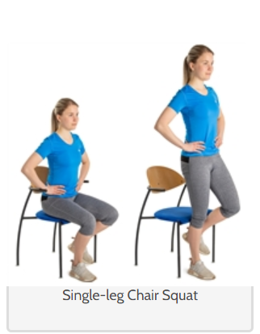

Exercise 2: Single leg Romanian Deadlift
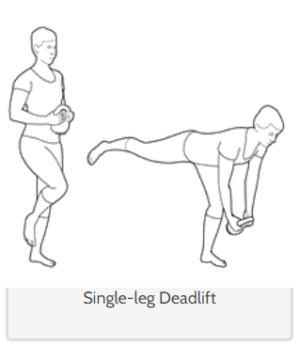

Exercise 3: Curtsy lunge
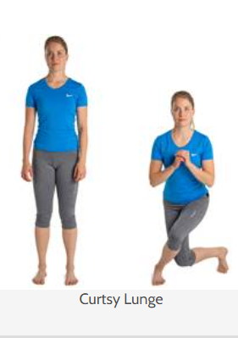

Exercise 4: step up
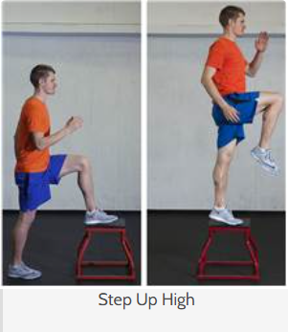

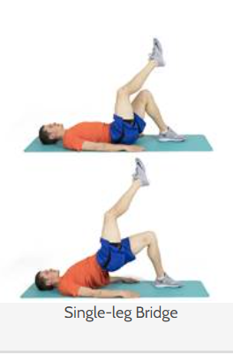
Exercise 5: Single leg bridge

Exercise 6: Single leg heel raise
